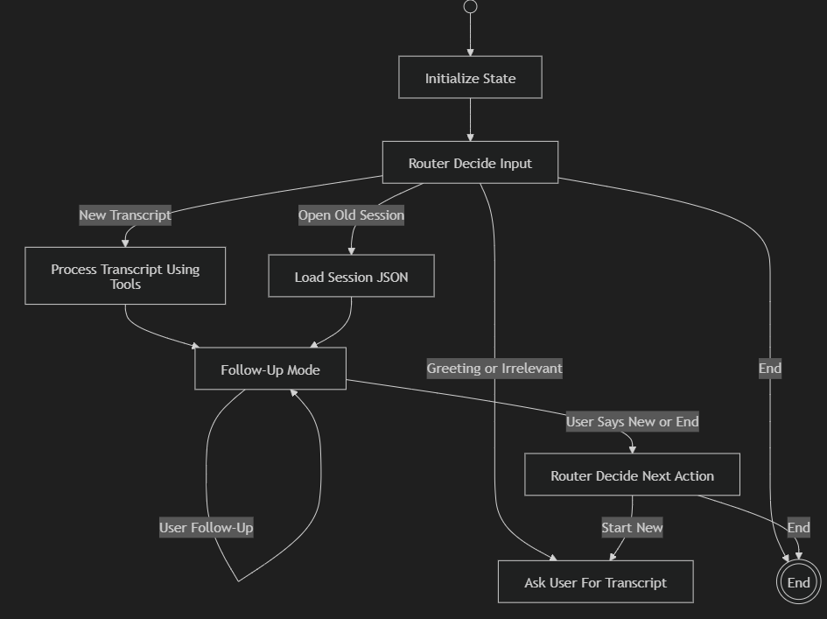

✅ 1. Start Node
Purpose
This is the graph entry point.
What happens here
- A new blank conversation state object is created
- All fields are initialized:
  - transcript = None
  - summary = None
  - tasks = []
  - session_id = None
  - mode = “idle”
Routing
Start → Initialize State
There is no branching here. It always goes straight to “Initialize State”.

✅ 2. Initialize State
Purpose
This node sets up the environment and then hands control to the main router.
Routing
Initialize State → Router Decide Input
Again, no branching — it always goes to the first router.

✅ 3. Router Decide Input
This is the most important node in your whole system.
This router determines what the user just did.
Inputs it can detect
This router evaluates:
- the user’s message
- the UI event (button clicks)
- the conversation state
Conditions + Routes
✅ 1. If user uploads a NEW transcript file
if state.file_uploaded and file_is_new:
→ Process Transcript Using Tools
✅ 2. If user selects an OLD session (from UI)
if state.selected_session_id:
→ Load Session JSON
✅ 3. If user says “hi”, “hello”, or irrelevant messages
if text_intent == greeting or irrelevant:
→ Ask User For Transcript
✅ 4. If user explicitly says “end session” or UI → End
if text_intent == end or UI_end_clicked:
→ End Session

✅ 4. Process Transcript Using Tools
Purpose
This node performs ALL tool-based operations:
- Extract text
- Summarize
- Extract tasks
- Classify priority
- Save JSON session
Routing
When processing finishes:
Process Transcript → Follow-Up Mode
No branches here — after analysis, the agent always enters follow-up mode.

✅ 5. Load Session JSON
Purpose
Loads previously saved meeting data:
- summary
- tasks
- priorities
- transcript
- metadata
Routing
After loading:
Load Session → Follow-Up Mode
Again, no branching.
If session is loaded, the agent is ready for follow-up.

✅ 6. Follow-Up Mode
This is your conversation loop node.
Purpose
Handle user questions like:
- “Give me the summary”
- “What are the action items?”
- “Show high priority tasks”
- “What did John say?”
Routing Behaviors
✅ 1. If user asks a follow-up question
if intent == follow_up_question:
→ Follow-Up Mode (loop back to self)
This creates the infinite follow-up loop.
✅ 2. If user types “new meeting” or “start new”
if intent == new_meeting:
→ Router Decide Next Action
✅ 3. If user types “end session”
if intent == end:
→ Router Decide Next Action
This node ONLY transitions when user types a command.
UI buttons bypass this router completely.

✅ 7. Router Decide Next Action
This router makes decisions only during follow-up mode, after user types “new” or “end”.
Routes
✅ If user says “start new meeting”
→ Ask User For Transcript
✅ If user says “end session”
→ End Session
There are only two branches here — very clean.

✅ 8. Ask User For Transcript
Purpose
This node displays a message:
“Please upload your meeting transcript.”
Routing
Ask User For Transcript → (wait for user)
After this, the graph returns back to:
→ Router Decide Input
Because user will either upload a file, greet, or type something else.

✅ 9. End Session
Purpose
Terminate execution cleanly.
Routing
End Session → stop graph
This is the terminal node.

✅ 1. Start Node (Start)
✅ Purpose
This is the entry point of the entire graph.
LangGraph automatically begins execution here.
✅ What Happens
- The graph engine boots up.
- A fresh state object is created in memory.
- All variables are initialized to default values.
✅ State After This Node
state = {
transcript: None,
summary: None,
tasks: [],
priority_tasks: [],
session_id: None,
loaded_session: None,
context: {},
mode: "idle"
}
✅ Routing
Start → Initialize State

✅ 2. Initialize State (Initialize State)
✅ Purpose
Prepare the agent for use by resetting or initializing all internal state fields.
✅ What Happens
- Clears any leftover conversation state from previous runs.
- Ensures the user's session is fresh.
- Prepares the environment for routing decisions.
✅ Routing
Always goes to:
Initialize State → Router Decide Input

✅ 3. Router Decide Input (Router Decide Input)
✅ This is the main brain of the agent.
✅ It is the most important decision-making node.
✅ Purpose
This node interprets the user’s very first action of the session.
✅ Inputs It Can Recognize
- A new transcript file (PDF/DOC/TXT)
- Selection of an old session from UI
- A greeting (“hi”, “hello”, “hey”)
- Irrelevant text
- Explicit end command (“end session”)
- UI “End” button
✅ Internal Logic (What It Decides)
✅ 1. User uploads a NEW transcript
→ Process Transcript Using Tools
✅ 2. User selects an OLD session from UI
→ Load Session JSON
✅ 3. User types greeting or something meaningless
→ Ask User For Transcript
✅ 4. User explicitly ends the session
→ End Session
✅ Routing Summary
New Transcript → Process Transcript
Old Session → Load Session JSON
Greeting → Ask User For Transcript
End → End Session

✅ 4. Process Transcript Using Tools (Process Transcript Using Tools)
✅ Purpose
This is your core AI work node.
Everything related to meeting analysis happens here.
✅ What Happens Inside This Node
It uses multiple tools:
- Text Extraction Tool
Extracts text from PDF/DOC/TXT.
- Summarizer Tool
Generates the meeting summary.
- Task Extraction Tool
Identifies tasks, owners, deadlines, blockers.
- Priority Classification Tool
Labels tasks as High/Medium/Low.
- Save Session Tool
Creates a JSON file:
- /sessions/meeting-XX.json
✅ Routing
When processing completes:
Process Transcript → Follow-Up Mode

✅ 5. Load Session JSON (Load Session JSON)
✅ Purpose
Loads old meeting data already saved earlier.
✅ What Happens
- Reads JSON file from /sessions/...
- Hydrates:
  - summary
  - tasks
  - priorities
  - metadata
  - transcript
- Prepares agent for follow-up questions
✅ Routing
Load Session JSON → Follow-Up Mode

✅ 6. Follow-Up Mode (Follow-Up Mode)
✅ This is the conversation loop node.
✅ The user can ask unlimited questions.
✅ Purpose
Answer all meeting-related questions after a session is processed or loaded.
✅ What this node handles
- “Show me the summary”
- “List the action items”
- “What are the deadlines?”
- “Show high priority tasks”
- “What did John say about budget?”
- “Give me risks”
- “Tell me all decisions taken”
✅ Routing Logic
✅ 1. If user asks normal follow-up questions
Follow-Up Mode → Follow-Up Mode (loop)
✅ 2. If user wants to start a new meeting
(User says: “new meeting”, “start again”, “analyze next file”)
→ Router Decide Next Action
✅ 3. If user wants to end the session
→ Router Decide Next Action

✅ 7. Router Decide Next Action (Router Decide Next Action)
✅ This router ONLY triggers during follow-up mode.
✅ It decides how the session transitions.
✅ Purpose
Decide if the user wants:
- to continue (not needed, loop handles it)
- to start a new session
- to end the conversation
✅ Routing Logic
✅ 1. If user says “start new” / “new meeting”
→ Ask User For Transcript
✅ 2. If user says “end session”
→ End Session

✅ 8. Ask User For Transcript (Ask User For Transcript)
✅ Purpose
Ask the user to upload a file when the agent needs a new meeting transcript.
✅ When It Is Triggered
- User greeted the agent with no transcript
- User selected "new meeting"
- User typed something irrelevant before giving a file
✅ Routing
The next user action will return to:
Ask User For Transcript → Router Decide Input
This resets the flow and waits for the user to upload.

✅ 9. End Session (End Session)
✅ Purpose
Stop the entire graph run cleanly.
✅ What Happens
- Clears temporary memory
- Ends the agent execution
- LangGraph stops routing
- UI resets to idle state
✅ Routing
End Session → TERMINATE

Problem Statement — AI-Powered Meeting Intelligence & Session Management System
Modern teams across industries conduct frequent meetings to discuss plans, review progress, and assign responsibilities. However, these meetings generate unstructured, scattered, and difficult-to-search information in the form of transcripts, recordings, and notes. After the meeting ends, teams struggle to:
- extract key decisions
- track action items
- identify responsible owners
- understand priorities
- recall past meetings
- compare historical discussions
- keep continuity between sessions
Most existing tools only provide static transcript dumps, leaving the user to manually re-read tens of pages to find meaning. This results in:
- lost tasks
- forgotten commitments
- duplicated discussions
- miscommunication
- inability to retrieve past meeting insights
Therefore, there is a clear need for an intelligent, agentic meeting assistant that can autonomously analyze, summarize, store, and retrieve insights from meeting transcripts across multiple sessions.

✅ Core Problem
Teams lack an intelligent system capable of:
✅ 1. Understanding and processing meeting transcripts
Meetings often produce long PDF, DOCX, or TXT transcripts. Manually analyzing them wastes time and introduces human error.
✅ 2. Extracting actionable insights automatically
There is no automated way to derive summaries, tasks, priorities, deadlines, responsibilities, or decisions — all of which are essential for accountability.
✅ 3. Maintaining continuity across multiple meetings
Teams need to retrieve what happened in:
- last week’s meeting
- a design review
- a sprint retrospective
- a client discussion
But they have to manually search through files.
✅ 4. Storing processed meeting intelligence in an organized, machine-readable format
Users need the ability to load previous meetings as structured data, not raw text.
✅ 5. Handling natural conversational follow-up questions
Users should be able to ask:
- “What were the action items last time?”
- “What did John say about infrastructure costs?”
- “Show me high priority tasks only.”
But this requires a stateful AI agent with contextual memory.
✅ 6. Switching between sessions dynamically
The system must allow:
- opening past meetings from a list
- analyzing new meetings
- ending a session
- resetting the workflow
without confusing the model.

✅ Objective / What the System Must Solve
The purpose of this project is to build a fully agentic, multi-session AI meeting assistant that can:
✅ Accept meeting transcripts in multiple formats
- PDF
- DOC / DOCX
- TXT
✅ Process them using specialized tools
- text extraction
- summarization
- task mining
- priority classification
- embedding generation
- session saving
✅ Store all processed meetings as local JSON sessions, containing:
- summary
- tasks
- priority tasks
- structured metadata
- raw transcript
- embeddings
✅ Load and switch between sessions on demand
Users can open:
- meeting-1
- meeting-5
- design-review
- sprint-planning
and continue follow-up.
✅ Enable unlimited follow-up questions
The system behaves like a knowledgeable assistant that knows everything from that meeting.
✅ Handle conversational flow using agentic routing
The agent must intelligently decide:
- Is the user starting a new meeting?
- Is the user opening an old meeting?
- Is the user asking follow-up questions?
- Did the user greet?
- Is this irrelevant text?
- Should the session end?
All of this must be handled by two routers, ensuring a stable workflow.
✅ A single intelligent agent
with
✅ autonomous decision-making
✅ multi-tool orchestration
✅ JSON session management
✅ natural language follow-up handling
✅ robust routing logic
this is my configuration: -
from langchain_openai import ChatOpenAI
from dotenv import load_dotenv
import os

load_dotenv()

def get_llm():
api_key = os.getenv("OPENAI_API_KEY")
base_url = os.getenv("OPENAI_BASE_URL")
model = os.getenv("OPENAI_MODEL", "us.anthropic.claude-sonnet-4-5-20250929-v1:0")

if not api_key:
print("⚠ WARNING: OPENAI_API_KEY not set in .env")

return ChatOpenAI(
api_key=api_key,
base_url=base_url,
model=model,
)

.env
OPENAI_API_KEY=
OPENAI_BASE_URL=https://openai.generative.engine.capgemini.com/v1
OPENAI_MODEL=us.anthropic.claude-sonnet-4-5-20250929-v1:0

